Project Name: Hcl Scholar Management.
Date: 02/02/23

Copyright Notice
This document contains proprietary information of HCL Technologies Ltd. No part of this document may be reproduced, stored, copied, or transmitted in any form or by means of electronic, mechanical, photocopying or otherwise, without the express consent of HCL Technologies. This document is intended for internal circulation only and not meant for external distribution.

Revision History
Version No | Date | Prepared by / Modified by | Significant Changes
Scholar 1.0 | 25/01/23 | Surya, Akhil | -
Scholar 2.0 | 02/02/23 | Surya, Akhil | Changes at Get specific & Delete Scholar

Project Overview
The project is a Scholar management application that allows users to perform various functions such as adding scholar, viewing all the scholars, viewing specific scholar by their id, deleting a specific scholar details by using their id and updating a specific scholar details using their id. The application is built using Java and uses a MySQL database for storing customer information.

Scope
The application will allow users to perform the following functions:
- Add new scholar to the system
- Viewing all the scholar’s details in the database of the application
- Viewing a specific scholar details in the database of the application based on their id
- Deleting a specific scholar details from the database of the application based on their id
- Updating a specific scholar details in the database of the application based on their id
- Exiting the application after using the application

Out of Scope
The application will not include any additional functions such grading a scholar or changing the gender of scholar.

Intended Audience
The intended audience for this application is trainers and managers who will be responsible for managing scholar information

High Level Use Cases
- Add new scholar to the system
- Viewing all the scholar’s details in the database of the application
- Viewing a specific scholar details in the database of the application based on their id
- Deleting a specific scholar details from the database of the application based on their id
- Updating a specific scholar details in the database of the application based on their id
- Exiting the application after using the application

Use Cases detailed
- Add Scholar: Allows managers and trainers to add a new scholar to the system by entering their personal details.
- Show All Scholar: Allows managers and trainers to view all scholar details from the database
- Get Scholar based on id: Allows managers and trainers to view a specific scholar details from the database based on the scholar id
- Delete Scholar: Allows managers and trainers to delete a specific scholar details from the database based on the scholar id
- Update Scholar: Allows managers and trainers to update a specific scholar details in the database based on the scholar id
- Exit: Allows managers and trainers to exit the application after using.

User Interface Modules
The application will have a user interface that allows manager or trainer to perform the various functions as described in the use cases.

Technical Architecture
The application is built in Java, JDBC and uses MySQL database for storing scholar information.

Technical Detailed Description
The application will use Java as the programming language and will make use of JDBC to connect to the MySQL database. The database will store customer information such as name, age, Sap Id, Location. The application will also use a user interface to allow managers and trainers to perform the various functions described in the use cases.

Sequence Diagram
A sequence diagram would be a visual representation of the interactions between the different components of the system and the order in which these interactions occur.

Database Entity Relationship Diagram
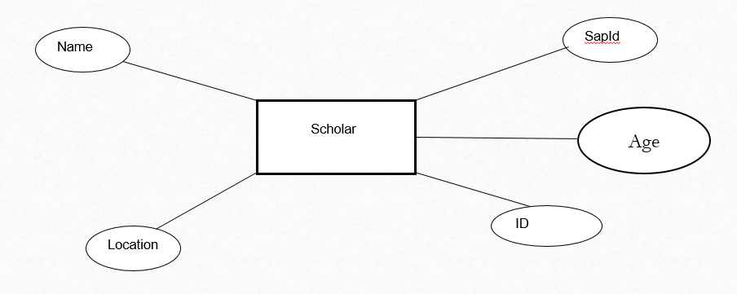

Standards
The application will adhere to industry standards for Java and MySQL development.

Non Functional Requirements

- Security: The application will need to ensure that scholar information is protected and that only authorized users can access it.
- Performance: The application will need to respond quickly to user requests in order to provide a good user experience.
- Scalability: The application will need to be able to handle an increasing number of scholars details as joined to the database.

